**Screenshot:**

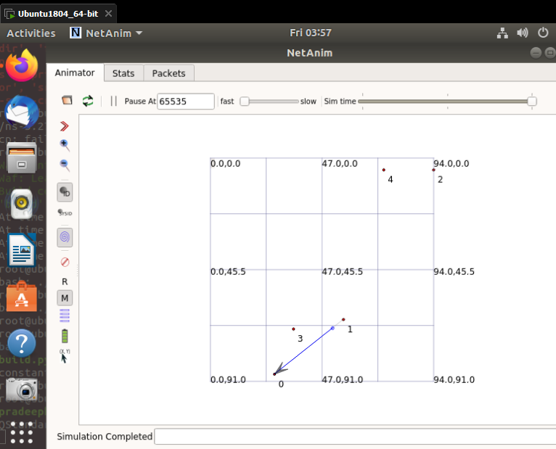

**Explanation:**

In this we learnt about netanim application that enables us to visualize and analyze the communication between nodes in a network.

It is generally used for analyzing a network spread through a large area. (For Eg: Forests etc.)